First Announcement

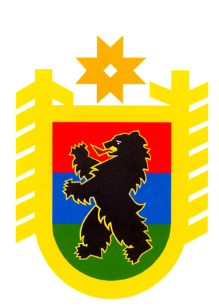
The Ministry of the Republic of Karelia  on National Politics  and Relations with Religious Associations | The Ministry of Education  of the Republic of Karelia | The State Committee  of the Republic of Karelia on Youth Affairs
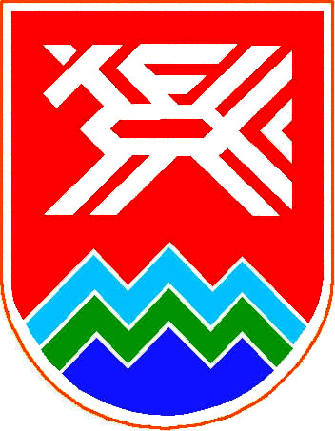 |  | 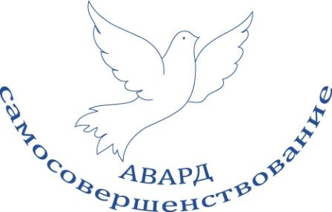
Karelian Research Centre  of the Russian Academy of Science | Non-profit Partnership  “Centre for Problems of the North,  Arctic and Cross-border Cooperation” | Interregional Youth Movement  “AWARD Association”
With support of

The Ministry of Health and Social  Development of the Republic of Karelia | The Ministry of Agriculture,  Fish Industry and Ecology  of the Republic of Karelia | The Ministry of Labour and Employment  of the Republic of Karelia
 |  | 
Petrozavodsk State University | Karelian State Pedagogical Academy | The Karelian Branch of the North-West  Academy of Public Administration
 |  | 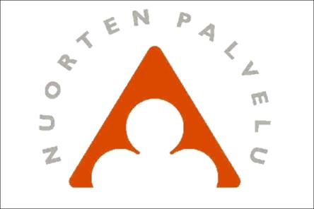
Council of Young Scientists and  Specialists of Republic of Karelia | Thule Institute,  University of Oulu | Youth Service of Finland

Local Administration of Pryazhinsky district

Are pleased to invite you to take part in

International Conference

Harmony of the North: Man and Nature. Youth View

November 25-26, 2010

Petrozavodsk, Karelia, Russia

Conference objective and themes:
The main scientific problem the conference shall focus on is finding solutions for sustainable development of Northern regions, and making them more attractive for the youth to live in. Such solutions should be based on the interdisciplinary approach and efficient utilization of human creative potential.
The conference shall reveal the demand for professional self-actualization among creative youth and for stimulation of young scientists’ involvement in basic and applied research, as well as encourage formation of international and interregional youth research groups and teams. The conference also aims to promote awareness of scientific findings and initiatives among the youth, to raise the appeal of science and creative industries to the youth as the basis for generation of an attractive living environment in the North.

Provisional results of the conference:
The main outputs of the conference shall be the proposals and developments by young scientists, youth NGOs and creative groups concerned with making Northern regions more attractive as a living and self-actualization environment, and with efficient utilization of the intellectual, natural resource and cultural potential of the North. An important practical result would be international and interregional scientific networks of young researchers from scientific, educational and civil organizations, as well as the possibility to make arrangements for joint research projects.
The conference shall be organized as a discussion forum where solutions can be worked out by combining theoretical and practical aspects of socio-economic, cultural and environmental problems. The conference shall produce a resolution and a letter to state authorities representing the young scientists’ view on the problem of harmony between Man and Nature in the North, and proposals on making the North a territory where the youth would want to live and self-actualize.

Proceedings of the Conference will be published.

The sessions are going to be arranged according to the following topics and issues:

Northern Economy: Structural Change and New Opportunities
- distinctive features of economic development, and competitive capacity of northern regions and remote cities;
- postindustrial transformation and modernization of the economy of the North;
- new opportunities for Northern countries and regions in the knowledge economy;
- local communities, and intellectual potential of Northern regions;
- settlement system, and new forms of spatial organization in the North;

Environment and Sustainable Nature Use in the North
- “Green Belt of Fennoscandia” – a modern model for sustainable development of northern natural complexes, and establishment of the integrated social-environmental-economic space that would best conserve northern nature and facilitate comprehensive development of border areas with regard to their historical, ethnocultural and economic peculiarities;
- regulation of interconnections between economic development and nature conservation as a key factor for optimization of nature use;
- problems of utilization, management and restoration of natural resources in the North;
- Northern water objects – unique characteristics, and conservation with view to environment friendliness and human environmental safety;
- working out of environmentally justified regional development strategies and concepts for development of the urban infrastructure and recreational areas;
- modern architecture, design, landscape planning in northern settings.

Cultural and Natural Heritage in the North
- raising the living standard in the North and making it more attractive for settlement through harmonious development of people in their native cultural and natural surroundings;
- studies of the cultural, historical and natural heritage of border areas in the North with view to involving them in the economy;
- ethnic communities of the North, and their cultural potential;
- promotion of the creative potential of the youth and adults to facilitate their self-actualization in the North.

Human Health in the North
- problems of maintaining the health of people living in the North in relation to exposure to extreme climatic, geophysical and anthropoecological conditions in high latitudes;
- development prospects of circumpolar medicine, application of its expertise in dealing with life extension issues, prevention and treatment of human diseases, maintenance of psychological health;
- possibilities to influence demographic processes in northern regions;
- harmonious development of the man amidst the northern nature;
- environmental education and awareness-building, shaping environmental culture in people, finding ways for the society to support sustainable development and environmental safety ideas.

The Conference Organizing Committee would welcome your proposals on potential formats and topics of the conference.

Working languages: Russian and English.

PROVISIONAL SCHEDULE OF THE CONFERENCE*

November 25th

Conference venue: Petrozavodsk, Karelian Research Centre of RAS and other partners’ sites&facilities

09:00 - Registration of participants

10:00 - Opening of the Conference

11:00-13:30 Plenary session

13:30-14:30 Lunch break

14:30-18:00 Thematic sessions:

Session 1 “Northern Economy: Structural Change and New Opportunities”

Session 2 “Environment and Sustainable Nature Use in the North”

Session 3 “Cultural and spiritual development of the North. Opportunities for creative self-actualization of the youth in the North”

Session 4 “Human health and ways to generate a comfortable living environment in the North”

19:00 - Cultural programme

November 26th

Conference venue: Pryazhinsky District, Republic of Karelia

10:00-16:00 Extramural session

Trip to Pryazhinsky District, Republic of Karelia to see how sustainable development solution based on balanced interactions between man and nature in the North have been implemented.

*Provisional programme of the conference and other practical information will be sent in the Second announcement

TERMS OF PARTICIPATION AND REGISTRATION

- Participation in the conference is free of charge

- Participants cover their own direct costs of travel to Petrozavodsk and back, accommodation and meals

- Official party on the first working day of the conference is a gratis event hosted by the organizers

- The organizers may consider covering accommodation expenses for key speakers (upon request)

- Applications for participation (Annex 1) are to be delivered before October 1, 2010 at the e-mail address info@northcentre.ru or fax number +7 814 2 76-96-00

- The materials to be published in the volume, including conference papers, are to be submitted to the Organizing Committee no later than November 1, 2010. Format requirements shall be sent to you upon request.

Contact information:

Igor N. Shevchuk  Karelian Research Centre of the Russian Academy of Sciences  Non-profit Partnership "Centre for Problems of the North, Arctic and Cross-border Cooperation"  (North-Centre) | Address: 11 Pushkinskaya st.,185910  Petrozavodsk, Russia  tel. +7 8142 78-01-09  cell. +7 9114046770  fax +7 8142 76-96-00  info@northcentre.ru

Annex 1
International Conference

Harmony of the North: Man and Nature. Youth View

November 25-26, 2010

Petrozavodsk, Karelia, Russia

APPLICATIOn FORM
1. Personal Data
First name, Last Name

Permanent Residence (country, city/town)

Date of Birth

Place of Work, occupation/status
Phone  (country code, number) |  |  | Fax  (country code, number) |  | E-mail

2. Participation

Would You like to present a report at the conference? | Yes | No

Subject of the report / Title

Participation in certain events of the Conference (please, mark)

Plenary session and Workshops (25th November)
Extramural session, Pryazhinsky District (26th November)

3. Additional Information

Please, mark the preferable variant of accommodation
Hotel accommodation | No accommodation needed

Information about arrival / departure

Arrival to Petrozavodsk | Departure from Petrozavodsk
Date of Arrival | Date of Departure
Time of Arrival | Time of Departure

