Alive Arctic Art – 2010
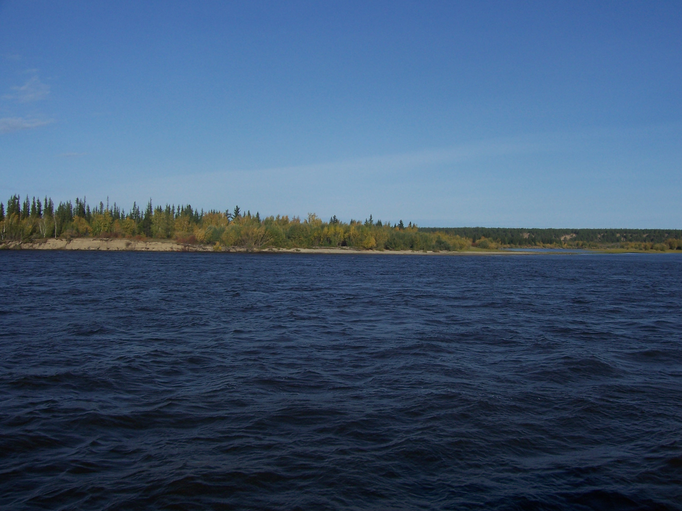
The “Alive Arctic Art” is a four week course that will be interesting for students, teachers and researches who will see culture of peoples of the North, for musicians who will study Yakut folk musical instrument – khomus, for artists, craftsmen and for everyone who just want to plunge into atmosphere of traditional life of Arctic.
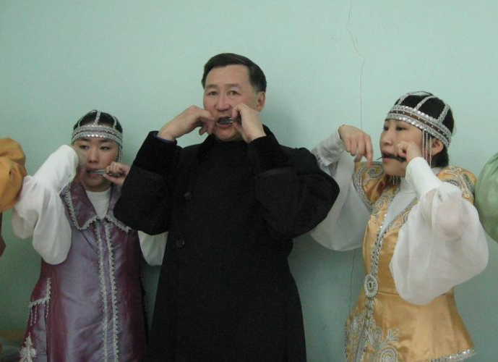
During the courses you will stay in “Grafskiy bereg” village, Namskiy region – one of the most beautiful, picturesque and peaceful places of central Yakutia. This is the best place to feel Yakutia, to learn more about traditional life of Yakut people and just to enjoy unique nature of our Republic.
Program courses:
- Folk musical instrument – Khomus
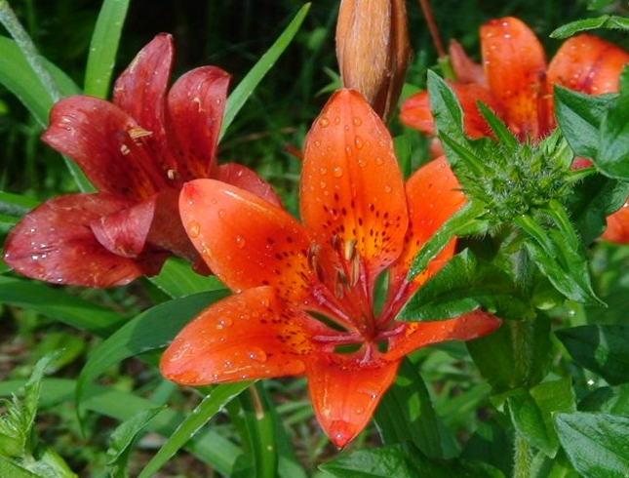
The course includes study of its construction, function and technique holding the instrument. You will study main sounds, technique of breathing, methods of playing, imitation of different sounds (swan, lark, throat, lip etc.) and main moments of improvisation.
- Folk singing
On this course you will study main conceptions of folk singing genre, peculiarities of singing style, main sounds of singing, technique of breathing while singing, different styles (Toyuk, Degern, Olonkho) and peculiarities of a folk singing.
- Bone and stone carving. Engraving.
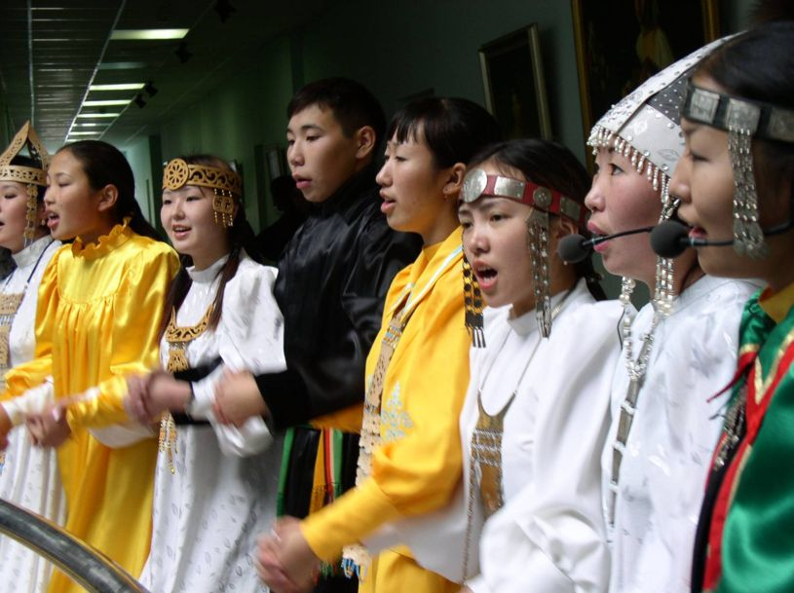
You will study volume carving, penetrating carving. You will be taught making ornamentals, caskets, and knifes. Materials – mammoth task, moose horn, Green stone.
Program cost
Program cost is 700 Euro, it includes:
- Accomodation in “Grafskiy bereg” village
- Cultural activities (Excursions to museums, theaters, concerts, social and cultural events)
- Transfer from and to Yakutsk Airport
- Transportation Yakutsk-Grafskiy bereg-Yakutsk
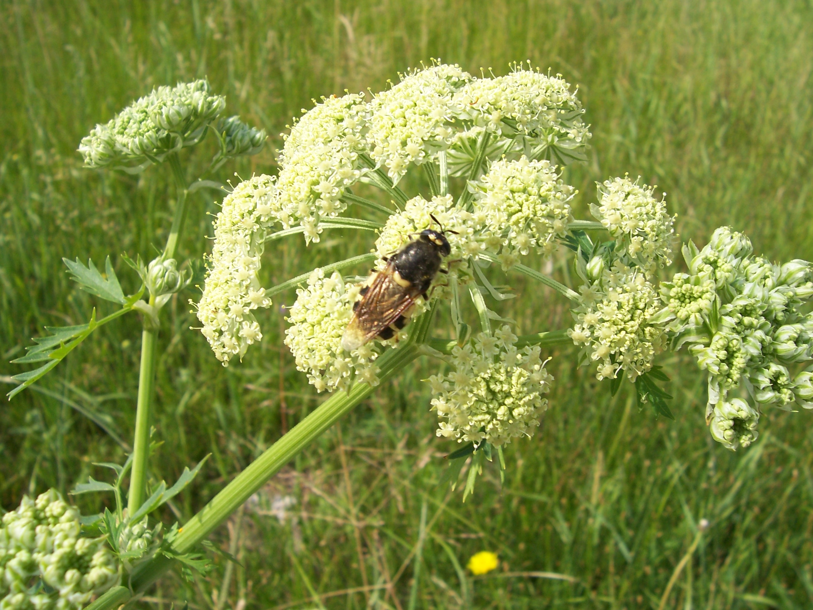

Program supervisor: Sardana Savvina,
International Office, Arctic state institute of arts and culture, Yakutsk, Republic Sakha
Registration deadline: 30 April 2010
How to apply: You need to complete the application form and send it to the International Office of ASIAC by email:
ssardaana@mail.ru, or fax: +7(4112)421167 before the deadline

