Yakutsk State University after M.K. Ammosov,
Faculty of Geology and Survey and
“Mineral raw material resources and evaluation technologies” research educational center

invite undergraduate and post-graduate students to join Summer Geological School.

Research supervisor: Prof. Valery Yurievich Fridovsky, Doctor of Geology and Mineralogy

Venue:
Russia, Sakha Republic (Yakutia)
Verkhne-Indigirsky gold-ore zone
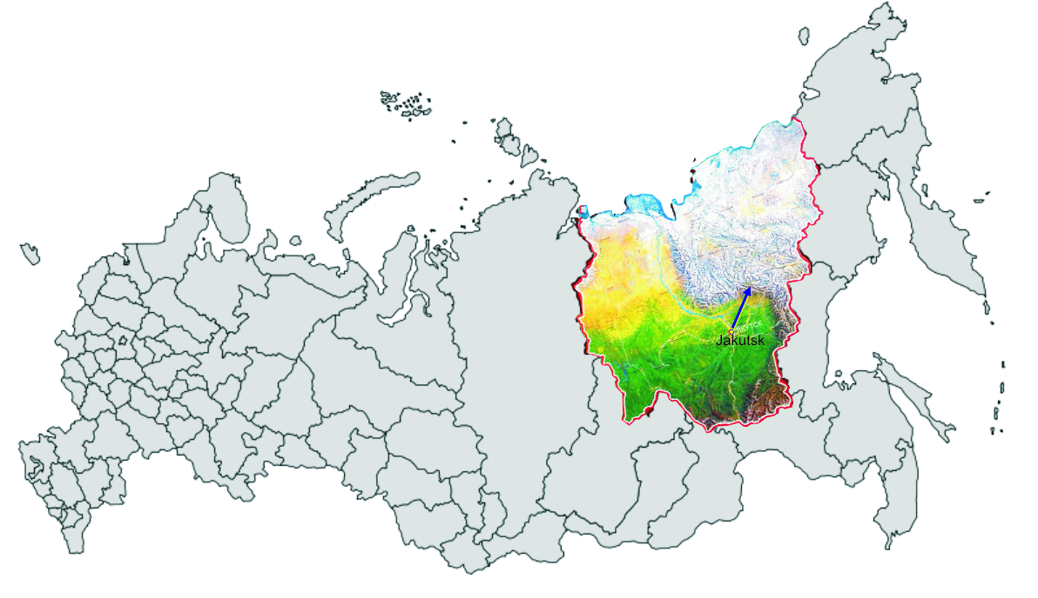

Period: July 01-July 30, 2010

The goal of the Scientific Field Geological School is to provide undergraduate and postgraduate students who conduct studies in the field of geology with opportunity to learn about principles of structure formation and tectonics of large gold ore deposits – the ore clusters in Mesozoic collisional-accretionary belts of the eastern margin of North-Asian craton.

The school program includes field studies, analyses of the obtained data and research results presentation on the following subjects:
- Structural-tectonic analyses of the orogenic belts (on the example of Verkhoyansk fold and thrust belt);
- Reconstruction of the tectonic structure formation cycle in various zones of the continental margin.
- Mineralogical geochemical zonation of gold- ore objects.
- Geotectonic mapping of terrigenous strata located in complex areas

Application deadline: May 20, 2010
Application form is available at www.ysu.ru and should be sent to oip-yakutsk@mail.ru

