SUMMER IN SIBERIA – 2010

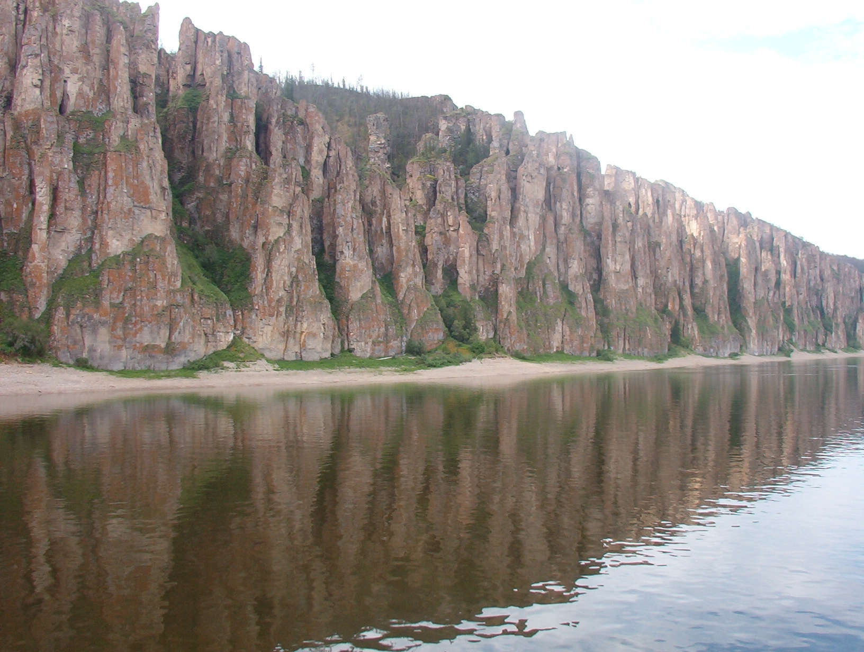
The “SUMMER IN SIBERIA” Russian language and Culture course is a wonderful opportunity to immerse yourself in the multicultural society of Yakutia in North East Siberia for nine weeks. Witness the historic social and economic changes occurring in Russia as you develop language skills in a Russian speaking environment.

Yakutsk State University is located in Yakutsk, the capital and the largest city of the Sakha Republic (Yakutia).
Yakutia has much in common with Alaska, Canada and other northern countries: vast, sparsely populated lands rich in unspoiled beauty, abundant wildlife, natural resources, and ethnic and cultural diversity. The city of Yakutsk is on the Lena River. Summer weather is warm (30 – 35 C or 70's and 80's F) and dry.

I. SUMMER IN SIBERIA
Terms: June 7– July 30, 2010

Program Courses:
1. Elementary – Intermediate Russian
2. Advanced Russian
3. Yakutia: Land and People
4. Applied Arts

Program credits– 15 ECTS

Program description

1. Option 1
Elementary – Intermediate Russian
Introduction course of the Russian language. Immersion in the grammar, structure, and vocabulary of the Russian language. Emphasis on conversational Russian, with additional reading and writing.

2.Option 2
Advanced Russian
Immersion in the Russian language for advanced students. Emphasis on reading, translation, textual analysis and composition. Includes discussion of advanced topics in Russian grammar and language structure illustrated through various writing styles. Prerequisite: one - two years of Russian.

3. Yakutia: Land and People

An interdisciplinary course introducing various aspects of life in Yakutia: history, geography, political situation of contemporary Yakutia, culture, environment and people. Some of the classes will be taught in museums and ethnographic complexes. The course includes also a trip to a traditional Sakha village and immersion in rural life.

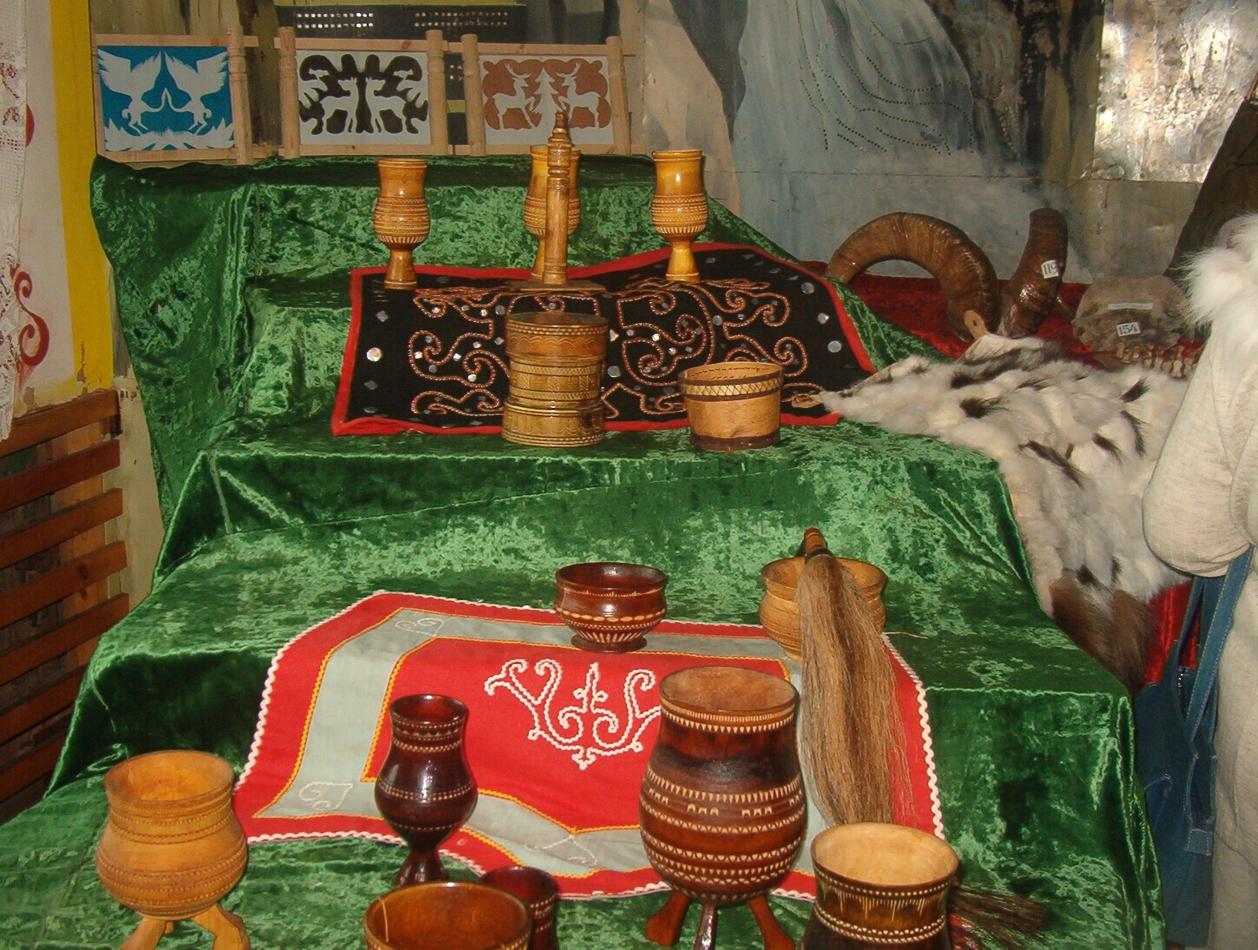
4. Applied Arts (Traditional sewing and embroidery of the peoples of Yakutia )
The course introduces the history of indigenous clothes, traditions of sewing and embroidery, contemporary tendencies, ways of translating cultural information in clothes as well as practical skills in needle work, bead work, etc. The course includes visits to the exhibitions of applied arts.
Accommodation: Yakutsk State University campus

Program cost
- Accommodation in double room – 270 Euro
- Cultural Activities – 80 Euro
(Excursions to museums, theaters, concerts, social and cultural events. Sakha traditional summer feast Ysyakh. Trip to the open - air museum “Druzhba”).
Trip to Sakha village (includes travel expenses, meals, accommodation) – 60 Euro
Total: 410 Euro

Program supervisor
Tatiana I. Olesova, Office of International programs, Yakutsk State University
oip-yakutsk@mail.ru

Registration deadline: March 22, 2010
How to apply:
Students need to complete the application form and send it to the Office of International programs of Yakutsk State University by email:
oip-yakutsk@mail.ru, or fax: + 7 (4112) 36 14 53 before the deadline.

