13th International Summer School in Karelia 2016

Main theme:
Arctic and Baltic Sea regional organisations: cooperation and policy-shaping with and without the EU

1st Call for Participation

Time: 16 – 21 May, 2016
(Travelling days from and to Finland 15 and 22 May)
Place: Petrozavodsk, Republic of Karelia, Russia

The International Summer/Spring School in Karelia (ISSK) is a meeting-point for Russian, and Finnish, as well as other Nordic and European, university students with a focus on European, Russian and Arctic/Northern studies. Since the initial Summer School in 2003, the goal has been to bring together a limited number (20-30) of students for one week at the Petrozavodsk State University (PetrSU) in order to further increase their knowledge of Nordic-Russian policies and cooperation, and promote studies and academic dialogue.

The ISSK is organized by the Petrozavodsk State University (Russia) and two Finnish universities, University of Lapland, and the Aleksanteri Institute at the University of Helsinki.

For whom As a multidisciplinary program, the ISSK'16 is purposed for the students of IR, political sciences, other relevant social sciences, and economics, geography and history, as well as students interested in European, Arctic and other Northern, and Nordic and Russian studies.
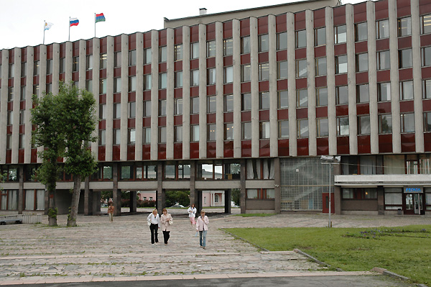

A stormy place: the city administration building at the lakeside
The theme: Arctic and Baltic Sea regional organisations: cooperation and policy-shaping with and without the EU (working title)

A new kind of interregional cooperation – for to decrease military tension and increase political stability – was started just after the end of the Cold War, and accelerated by the collapse of the Soviet Union, in the greater Northern Europe. The Baltic Sea Region was a forerunner of a new kind of trans-boundary cooperation across the former Iron Curtain, as both functional and institutional cooperation between universities, cities and states of the region show. Consequently, the Council of the Baltic Sea States (CBSS), including all states of the region as well as Iceland and Norway, was established in 1992. Regional cooperation in, and within, the Baltic Sea region is greatly supported by the Nordic countries, and Nordic cooperation more generally, with an outcome of the (N5+B3) NB8 cooperation. Correspondingly, the Barents Euro-Arctic Region (BEAR), including the Barents Euro-Arctic Council (BEAC), was established by Finland, Norway, Russia and Sweden, as well as the European Commission in 1993. Finally, the eight Arctic states – Canada, Denmark, Finland, Iceland, Norway, Russia, Sweden and the USA – established the Arctic Council (AC), based on the Arctic Environmental Protection Strategy (AEPS), in 1996. Each of the three regional councils has a focus of regional development, functional, much environmental, cooperation and policy-shaping. Further, the BEAC and the AC are good examples of having both states and indigenous peoples as recognized members of cooperation, and in the CBSS and the Barents Regional Council there are also sub-national governments involved. Finally, they are examples of, even models for, modern region-building by the states as major actors.

How to apply?

The application form is to be found here:
https://elomake.helsinki.fi/lomakkeet/40493/lomake.html

Fill the application by 21 March, 2016.

Each participant is supposed to apply for the visa to Russia in good time.

Please note! Due to the current visa registration rules of the Russian Federation, it is not possible to participate in the school with a tourist visa. If you need to apply for a visa for this purpose, you have to provide the Petrozavodsk State University with a scanned copy of your passport and the information that is asked in the end of this document. Instructions for it will be sent to you when you fill the application form.

Assessment
● For a successful completion of the course, each student is required to attend all lectures and the excursion, and actively participate in daily workshops.
● Additionally, each student needs to write an essay of 10-12 A4 pages, i.e. 22.000-26.000 items (not including the reference list, figures and tables) on a selected topic, relevant to the main theme of ISSK’16, and submit it to his/her university coordinator within one month after the completion of the course.
● With the requirements fulfilled, the course will carry up to 5 ECTS.

Costs
● There is no registration fee.
● The participation costs will consist of travel costs of travels between Finland and Petrozavodsk, plus meals, excursion, and the visa costs.
● Other costs, e.g. accommodation, lunches, possibly serving of coffee/tea in Petrozavodsk, will be covered by the organizers.

ISSK’16: Working methods and program structure

The ISSK’16 is a one week intensive course that will study issues on resources and security universally/globally, as well as regionally and locally, taking both more holistic and interdisciplinary approach as well as that of IR/Political sciences, and History. Through bringing together recognised experts from Finland and Russia, the ISSK’16 will provide students with an overview of state sovereignty in theory and in praxis in Northern Europe through case studies.

During the ISSK’16 these resources and security issues will be discussed on one hand in a local context in the Barents Sea area, and on the other hand, in a global context in the Arctic and holistically. Furthermore, security will be theoretically discussed, defined and (re)conceptualized including discussion on definition and terms, as well as scales, actors and entities of security. Finally, there will be case studies, such as environmental security, human security, food security and energy security.

Among others the lecturers of the 2016 ISSK will be prof. Lassi Heininen (University of Lapland), head of education Tapani Kaakkuriniemi (University of Helsinki), prof. Alexander Sergunin (St. Petersburg State University) (tbc), associate prof. Gleb Yarovoy (Petrozavodsk State University).

The sites of the ISSK’16 will be in the city of Petrozavodsk, Russia. The day of departure from Finland to Petrozavodsk is Sunday 17 May, and the return day Sunday 24 May, 2016.

Daily programme

Daily schedule of the ISSK consists of
● two theme lectures with open discussion in mornings;
● student workshop(s), supervised by the tutors and experts, in afternoons;
● social program in evenings.

Students will give their active contribution during the lectures, workshops and the final round-table discussion in order to increase their understanding of sovereignty issues in general and dealing with North Europe, as well as the Arctic region.

During the ISSK’16 there will be a half-day seminar on resources and security concentrating on the current situation of possible impacts and reflections of regional wars and the constant fighting on international terror to the high stability of the Barents Sea are and the entire Arctic region. The seminar will be organized together with the Department of Political and Social Sciences of the PetrSU and the Karelian Research Centre of the Russian Academy of Sciences (tbc).

Excursion
A full/half-day excursion within Karelia, to nearby sites of general interest will be organized as a part of the program of the ISSK’16 on the 21st of May (tbc).

Contact Information for ISSK’16

For additional information about the ISSK'16, do not hesitate to contact the director, the coordinator of the ISSK, Anastasia Kuznetsova at Petrozavodsk State University (kuznetsova.petrsu@gmail.com) and the members of the ISSK Steering Committee:

• Lassi Heininen, director University of Lapland lassi.heininen@ulapland.fi
• Tapani Kaakkuriniemi University of Helsinki tapani.kaakkuriniemi@helsinki.fi
• Liudmila Kulikovskaya Petrozavodsk State University kulikovskaya@psu.karelia.ru
• Anastasia Kuznetsova Petrozavodsk State University kuznetsova.petrsu@gmail.com

For more information of the ISSK see the website:
http://petrsu.ru/Structure/Inter/beuc.html
or
http://beuc.petrsu.ru/en/index.html.

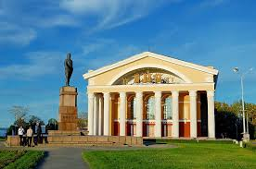

The statue of Sergei M. Kirov in front of the Kirov theatre
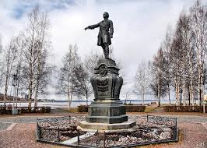

The statue of Tsar Peter I

