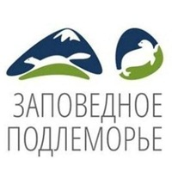
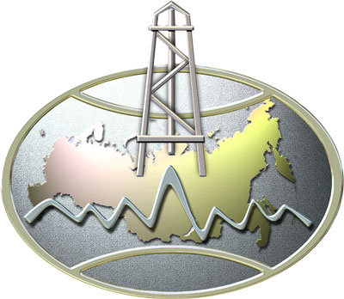
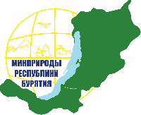


First call

Ministry of Natural Resources and Environment of the Russian Federation
Ministry of Natural Resources and Environment of the Republic of Buryatia
Institute of General and Experimental Biology, Siberian Branch of Russian Academy of Science
V.B. Sochava Institute of Geography, Siberian Branch of Russian Academy of Science
Federal State Establishment “United Administration of Barguzinsky State Nature Biosphere Reserve and Zabaikalsky National Park” (FSE “Zapovednoe Podlemorye”)

Russian National Conference with International Participation
“NATURE RESERVES AS THE PILLAR OF FUTURE”
Dedicated to the 100 Anniversary of Barguzinsky Zapovednik--Barguzinsky State Nature Biosphere Reserve-- and the “Year of the Environment” in Russia
September 7-8th, 2017
Ulan-Ude

On January 11 of 1917 the Governing Senate signed the Act of Organization of the first Nature Reserve in the country: Barguzinsky Zapovednik. For a hundred years the Reserve has been protecting nature. Established based on scientific studies, the reserve continues to be a leader of scientific research in Protected Areas.

Dear colleagues,
Throughout 2017 we are celebrating the 100th anniversary of Barguzinsky Nature State Biosphere Reserve. This September's Forum and Conference, “Nature Reserves as the Pillar of the Future,” will be the year's major environmental event dedicated to Barguzinsky. We invite you to take part in the national conference with international participation on applied science, “Nature Reserves as the Pillar of Future”, during which significant issues of conservation science will be discussed.

Key topics:
- Chronicles of Nature;
- Monitoring of Protected Area;
- Connection between fundamental and applied science;
- Scientific approach in protection efforts;
- Environmental education and educational tourism in Protected Areas.

Russian is the official language of the conference. Simultaneous translation from Russian to English will be organized for international participants during plenary and parallel sessions.

Main dates:
Registration deadline – March 15th, 2017;
Paper submission deadline – June 1st, 2017;
Please forward application forms and papers to be published to Evgenia Bukharova <100let-konf@pdmr.ru>

Application form
Last name
First name
Position, University/Organization
Academic Title
Telephone
Fax
E-mail
Address
Title of Paper
Presentation type | ☐Oral ☐ Poster
Attendance | ☐ In person (I can attend the conference)  ☐ By correspondence (I would like to send a paper, but I can not attend)

Document format:
Papers are limited in length to five pages including images, tables and references. Documents are in the *.rtf format.
The paper size is A4 (i.e., 210 x 297mm), with a 2 cm margin at the top, bottom, left and right. Lines are single-spaced. The body of the text should be as follows: 12pt Times font, Single space, 1.25 paragraph spacing.
Paper layout:
- Name of paper: in English or Russian, centered with capital letters
- Initials and last names of authors centered
- Full name of the organization, city, email centered
- Abstract (200 to 300 words)
- Keywords (up to five)
- Text
- List of literature: capital letters, centered
- Images in separate files in *.tif (black and white) or *.jpg (greyscale), > 300 dpi, file name with last name of the author, image number (Petrov_001_ jpg, Petrov_002_ jpg, etc.)
- Literature: authors in italic, 10pt Times font, in alphabetical order with numbering (references in the text are in brackets with numbers according to their place in the list of literature).

Conference papers will be published in the Proceedings Book with ISBN and RSCI (Russian Science Citation Index).

The conference fee will be announced in the second information letter.

The conference will include workshops and field trips

Contact address of the organization committee: Lenina st. 71, town of Ust-Barguzin, Republic of Buryatia, Russia, 671623. Phone +7 (30131) 91-5-78.
Conference secretary: Evgenia Bukharova, email 100let-konf@pdmr.ru, Phone/Fax: +7 (3012) 441724; Cell: +79148340943, address: Komsomolskaya st. 44-64, city of Ulan-Ude.

Web-site: http://zapovednoe-podlemorye.ru/

