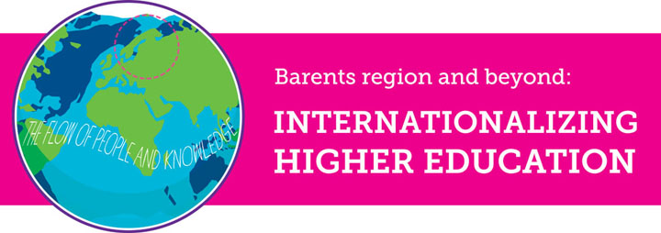
Tuesday 2nd June– Wednesday 3rd June 2015

Venue: University of Nordland, Bodø, Norway

In a time and world portrayed as increasingly globalized, cooperation between higher educational institutions (HEIs) is no more an odd event – rather, it has become a norm. But what do we know about such cooperation? What does international collaboration in education result in, for students, faculty and the involved nations? What can we learn from previous projects and what more do we need to know to be able to guarantee that such projects result in a successful outcome? Is it worthwhile to start up projects of international collaboration in education?

This conference is meant to be an arena for the exchange of knowledge, debate and discussion on International Educational Collaboration involving two or more HEIs.

At the conference, scholars who have taken part in the NORRUSS project titled “Higher Education in the High North: Regional Restructuring through Educational Exchanges and Student Mobility”, as teachers or researchers, will present research on their own experiences from an international collaboration in education between seven HEIs in North West Russia and HEIs in the northern part of Norway. Others are welcome to present their research on projects that likewise have dealt with internationalizing higher education. In addition to research papers, we also welcome presentations of reflected best-practices.

Keynote speakers:
- Susan Robertson, professor of Sociology of Education at the University of Bristol, UK
- Roger Dale, professor of Education at the University of Bristol, UK
- Vera Skorobogatova, journalist and a lawyer, Russia
- Scott Thoe, artist, Lofoten, Norway
- Ingvild Broch associate professor emeritus; Doctor honoris cause at Pomor State University Arkhangelsk, Russia, formerly special adviser, Norwegian Association for Higher Education Institutions
- Peter Maassen professor in Higher Education Studies, University of Oslo Norway
- Rune Rafaelsen, head of the Norwegian Barents Secretariat

For more information, and to register for the conference, please click HERE

